Developing the Second National Action Plan
Discussion paper
May 2022

© Commonwealth of Australia 2022
CREATIVE COMMONS BY ATTRIBUTION 4.0 INTERNATIONAL LICENCE
This publication is available for your use under a Creative Commons Attribution 4.0 Australia licence. With the exception of the Commonwealth Coat of Arms, the Agency logo, photographs, images, signature and where otherwise stated. This publication is licensed under a Creative Commons Attribution 4.0 International licence (CC BY 4.0), the full licence terms are available from https://creativecommons.org/ licenses/by/4.0/.
The licence is a standard form licence agreement that allows the copying, distribution, transmission and adaptation of this publication provided it is attributed to this publication.
THIRD PARTY COPYRIGHT
Wherever a third party holds copyright in this material, the copyright remains with that party. Their permission may be required to use the material. Please contact them directly.
ATTRIBUTION
This publication should be attributed as follows: © Commonwealth of Australia, National Recovery and Resilience Agency Second National Action Plan discussion paper, 2022.
DERIVATIVE MATERIAL
If you have modified or transformed the material, or derived new material from the publication the publication should be attributed as follows: Based on the Second National Action Plan discussion paper, 2022.
OTHER USES
Enquiries regarding the licence and any other use of this document are welcome at:
Social and Environmental Policy Team
121 Marcus Clarke Street
Canberra, ACT, 2601
E: nationalactionplan@recovery.gov.au

Discussion Paper

Request for feedback and comments
This discussion paper is just one component of a broader engagement process to inform and develop the second National Action Plan under the National Disaster Risk Reduction Framework. To date, several online forums, a public webinar, bilateral discussions, and a face-to-face workshop have been held. In addition to future deep dives and a complementary open survey (link here), a two-day From Risk to Resilience Summit will be held in late June 2022.

This discussion paper seeks stakeholder feedback on a range of systemic disaster risk issues. The National Recovery and Resilience Agency invites interested stakeholders to respond, sharing experiences, insights, and comments by 14 June 2022.

Submissions may be lodged electronically via email to nationalactionplan@recovery.gov.au. For accessibility reasons, please submit responses via email in a Word, RTF or PDF format.

Consolidated responses are preferred where applicable.

How your submission will be used
Submissions may be shared with other Commonwealth agencies and stakeholders where necessary for the purposes of the development of the second National Action Plan. Due to the strong alignment between the National Disaster Risk Reduction Framework and the Sendai Framework for Disaster Risk Reduction 2015-2030, your submission may also be used to inform the development of the national Mid-Term Review of the Sendai Framework. It may also be used to inform the review of the National Disaster Risk Reduction Framework scheduled for 2023.

All information (including name and address details) contained in submissions may be made publicly available unless you indicate that you would like all or part of your submission to remain in confidence. Automatically generated confidentiality statements in emails are not sufficient for this purpose.

If you would like only part of your submission to remain confidential, please provide this information clearly marked in your submission. Legal requirements, such as those imposed by the Freedom of Information Act 1982, may affect the confidentiality of your submission.

Closing date for submissions: 14 June 2022
Email submissions to: nationalactionplan@recovery.gov.au

Enquiries can be initially directed to: nationalactionplan@recovery.gov.au

Developing the Second National Action Plan

Introduction
All governments, businesses, communities, institutions and not for profit organisations need to collectively drive the development of a comprehensive program of measures aimed at reducing systemic disaster risk, increasing Australia’s resilience and minimising the harm caused by a rapidly changing climate and extreme weather events. Given the collective effort and responsibility required to achieve this aim, the second National Action Plan will be a product of consultation and collaboration.
The second National Action Plan will reflect the lead actions stakeholders consider necessary to enable focused, unified, and effective efforts by all sectors of the Australian economy and environmental, cultural and social interests. The second National Action Plan needs to be a developed by all sectors, for all sectors.

Setting the Scene: Australia’s reform agenda
In April 2019, the National Disaster Risk Reduction Framework (the Framework) was released and subsequently endorsed by the Council of Australian Governments on 13 March 2020.
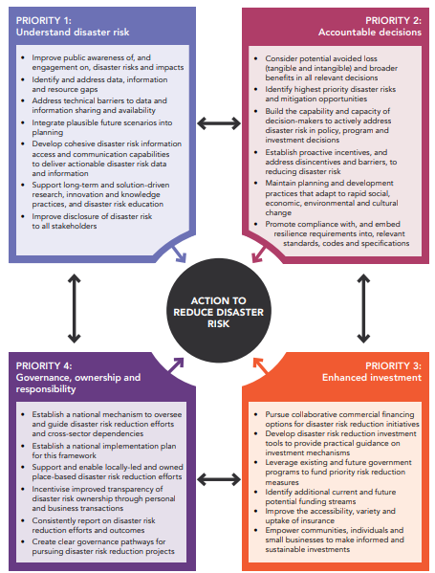
Figure 1: Actions to reduce disaster risk
Included in this Framework are four priority themes (Figure 1):

- Understand disaster risk
- Accountable decisions
- Enhanced investment
- Governance, ownership and responsibility
The Framework is the domestic translation of the Sendai Framework for Disaster Risk Reduction 2015-2030 and is also broadly aligned with the United Nations Sustainable Development Goals and the United Nations Framework Convention on Climate Change Paris Agreement.
The Framework will be reviewed in 2023 to ensure it remains current in a rapidly changing risk context. Consultation gathered from the development of the second National Action Plan will contribute to this work.
The Framework is underpinned by the report Profiling Australia’s Vulnerability: The interconnected causes and cascading effects of systemic disaster risk.
This report takes a systems-based and a values-based lens to understanding disaster risk. This report led to the realisation that what affects the nation’s resilience to disaster is the array of choices and decisions that have been made over generations and the decisions being made now that will affect future generations. The values and trade-offs inherent within these decisions have consequences, and getting the balance right is a complex challenge.
Since the Framework was developed, the occurrence of disasters in Australia that are beyond our historical experience and that test the limits of capacity and capability has continued. Most recently, the 2019-20 bushfires and the recent flooding across Queensland and New South Wales have brought into focus the challenges in reducing the risk, impact, and consequence of natural events on communities. These events expose the underlying drivers of disaster and draw attention to the nation’s tolerance for loss, the limitations of current emergency management arrangements for dealing with severe to catastrophic events beyond previous experience, and the need for all levels of government, institutions, businesses, critical infrastructure providers, communities, and individuals to think differently.
Natural hazards will continue to impact on Australian communities, businesses, and the built and natural environment. Strategic disaster risk reduction actions and investment pathways need to be collectively identified and actioned. These actions must help individuals, communities, organisations and governments limit their exposure and vulnerability to future disruption for the long term.

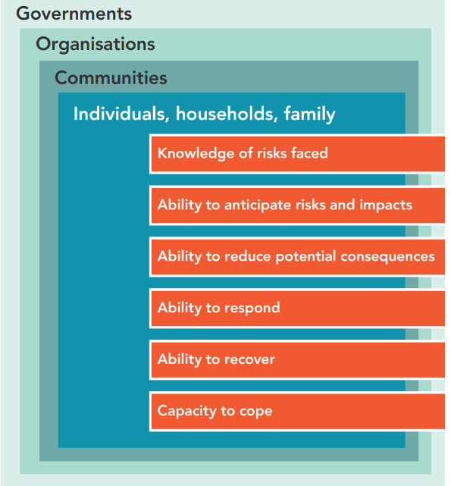
What can you do?
Figure 2: Features that effect the level of vulnerability and resilience
Everyone has a role to play and a responsibility to reduce systemic disaster risk. While we know people’s agency and institutional capacity to cope varies, there are several scalable attributes that are common to all (Figure 2).
We also know there is a myriad of innovative, multi-dimensional projects, strategies, and initiatives underway across the nation to improve capability and capacity.
With this in mind, we would like you to consider the questions posed in this Discussion Paper, reflect on the role you and/or your organisation play and let us know what would help you contribute more effectively to reducing disaster risk and build resilience.
Please do not feel your submission needs to be constrained to the questions posed; you may wish to address the issues and questions below directly, or use these as a guiding prompt for additional ideas and consideration.

What should be in the National Action Plan?
Growing concern about the impacts of a variable and rapidly changing climate combined with increasing potential for loss and harm are raising questions about what can be done differently to reduce Australia’s exposure and vulnerabilities to disruptions. It’s important that Australians can live and thrive in a country prone to intensifying natural hazards.
As the stability of natural, social and economic systems are increasingly at risk, awareness is growing that many of the things that individuals and communities currently value, are becoming threatened or lost.
The task of preventing natural hazards from developing into disasters is becoming more complex. Currently there are limits to what communities and individuals can do to reduce their risks (exposure and vulnerability) from disasters and to cope and recover during and after disruptions. The agency and influence that individuals, communities, organisations and governments have are not equal. For example, some are able to make decisions on behalf of others, some have disproportionate influence to increase or reduce vulnerability, while others are disproportionately vulnerable as they don’t have the resources or agency to address the causes of their exposure and vulnerability.
Systemic disaster risk reduction is about taking harm out of the system. It requires addressing the decision points where the risk of harm is created. These decisions and interventions to reduce disaster risk will need to span across critical infrastructure, climate adaptation, land use planning and development, updating standards and codes, provisioning of essential public services, housing, health, telecommunications, natural resource management, insurance, social policy, agriculture, education, community development, energy, and the environment.
Within this context, the second National Action Plan aims to elicit and consolidate the views, priorities and transformative/innovative actions from diverse sectors and stakeholders across Australian society with the purpose of helping align and unify system-wide efforts to address the nation’s most pressing climate and systemic disaster risk problems.
The second National Action Plan is a strategic opportunity to support and guide diverse stakeholders’ in coordinated efforts to change their behaviours and decisions to take harm out of our systems. It can also enable the realisation of opportunities to not only reduce the creation of future risk but to generate new value and benefits to people, assets, nature and infrastructure in ways that are disaster resilient and climate adapted.
For this to be effective or realised requires that everyone feels empowered to participate in creating the future we want. The questions below provide an opportunity for you to participate in this process. These questions are framed around the following:
- Understanding the systemic causes and impacts of climate and disaster risk
- The need to activate imagination and innovative thinking to generate transformative interventions and outcomes
- Incentivising coordinated system-wide actions that enable risk reduction, vulnerability reduction, increased preparedness, and resilience.
You will note the term ‘natural disaster’ is not used in this paper. This is deliberate and represents a global re-framing of what constitutes a disaster – recognising that while natural hazard events are inevitable, the impact they have on society is not.

Accordingly, the National Action Plan will be focused on targeted actions to reduce the underlying systemic drivers of disaster. Please keep this in mind when responding to the following questions.

Discussion Questions
Note: although it would be helpful, you do not have to answer all questions. The below questions are a guide for your submission.

Q1 What do you understand your shared responsibility to be for reducing systemic disaster risk (for yourself, your organisation or on behalf of others) and ideally, what should collaboration look like?

Q2 What examples can you share about what you are doing to prevent or limit the potential severity of future disruption arising from climate and disaster risks? What is working well, and what isn’t?

Q3 What is enabling your efforts to reduce disaster risks? Conversely, what is impeding your efforts to reduce disaster risks and why should it be addressed in the second National Action Plan?

Q4 If the second National Action Plan included ~5 nationally significant strategic initiatives or actions to focus collective efforts over the next 2-5 years, what should they be? What would make the most difference nationally?

Q5 Anything else you would like to add?

What’s next?

Further updates about the development of the second National Action plan will be provided here:
- https://knowledge.aidr.org.au/resources/second-national-action-plan-for-disaster-risk-reduction/
- www.recovery.gov.au/nap
Please contact the team via nationalactionplan@recovery.gov.au

Related resources
- National Disaster Risk Reduction Framework

- Profiling Australia’s Vulnerability: the interconnected causes and cascading effects of systemic disaster risk

- Guidance for Strategic Decisions on Climate and Disaster Risk (set of six documents)

- Australian Disaster Resilience Handbook Collection: Systemic Disaster Risk Handbook

- CSIRO report on the Climate and Disaster Resilience to the Prime Minister

You can learn more about this in the Profiling Australia’s Vulnerability: the interconnected causes and cascading effects of systemic disaster risk, or here: https://www.nonaturaldisasters.com/

