

A Community “What-if?” Exercise:

A Step-by-Step Planning Guide

Australian Disaster Resilience Handbook Collection

Companion to Managing Exercises (AIDR 2023)

This document complements *Managing Exercises* (AIDR 2023). It is available as an online resource on the Australian Disaster Resilience Knowledge Hub: [knowledge.aidr.org.au/resources/handbook-managing-exercises](https://afacau.sharepoint.com/sites/Comms/Shared%20Documents/Marketing/01_PROJECTS/2024/AIDR/Manage%20Exercises%20Toolkit/Hypothetical%20Exercise%20Toolkit/Export/This%20document%20complements%20Managing%20Exercises%20(AIDR%202023).%20It%20is%20available%20as%20an%20online%20resource%20on%20the%20Australian%20Disaster%20Resilience%20Knowledge%20Hub:%20knowledge.aidr.org.au/resources/handbook-managing-exercises/)

Acknowledgement

# This companion was prepared by the Australian Institute for Disaster Resilience with the assistance of Cheryl Durrant.

# Attribution

Where material from this publication is used for any purpose, it is to be attributed to the Australian Institute for Disaster Resilience as follows: A community "what-if" exercise: a step-by-step planning guide (AIDR 2024).

In no event shall the Australian Institute for Disaster Resilience be liable for any damages whatsoever, whether in an action of contract, negligence or other tortious action, arising out of or in connection with the use of or reliance on any of the information in this publication.

# Contact

Enquiries regarding the content and any use of this document are welcome at:

The Australian Institute for Disaster Resilience   
Level 1, 340 Albert Street, East Melbourne Vic 3002

Telephone +61 (0) 3 9419 2388

Email **enquiries@aidr.org.au**

## Introduction

A “what-if?” exercise is an easily accessible way for a community to think about and prepare for future emergencies and disasters. A “what-if?” exercise creates hypothetical scenarios by simply asking the question “**what-if?**” No specialised knowledge is needed to organise this style of exercise. A “what-if” exercise is a good way to start a community conversation about disaster preparedness, response or recovery.

## 1. Decide your purpose: aims and objectives

Before you start, you should be clear about your purpose and your audience for the exercise. To clarify your purpose, think about your overall aims and objectives.

“What-if?” exercises are good for learning, discovery, exploration and making connections. Your aims and objectives might begin with:

|  |  |
| --- | --- |
| * To discover * To learn * To explore * To understand | * To imagine * To build shared awareness * To develop connections * To know more about |

You could hold a “what-if?” exercise for your team, your organisation, a group of community organisations or for the whole community. A greater diversity of participants needs a bit more planning to manage but will give richer outcomes. You may wish to start with a smaller group and grow your participants as you become more familiar and comfortable with the process of planning and delivering an exercise.

You could hold a “what-if?” exercise for your team, your organisation, a group of community organisations or for the whole community. A greater diversity of participants needs a bit more planning to manage but will give richer outcomes. You may wish to start with a smaller group and grow your participants as you become more familiar and comfortable with the process of planning and delivering an exercise.

Be clear about your audience. Ask yourself:

|  |  |
| --- | --- |
| * Who am I doing this for? * Are they interested? | * How will they be engaged? * Who might benefit from participating? |

**Example Aim and Objectives:**

We are holding a community “what-if?” exercise **with local community groups** in our network **to explore** options for greater involvement of all community members in disaster preparedness.

Our exercise objectives are:  
\***To build shared awareness** about potential future disaster impacts  
\***To learn** more about our vulnerabilities and values  
\***To imagine** different ways of preparing and responding to disasters

Once you are clear on your aim and objectives it is time to develop some scenarios.

## 2. Generating alternate scenarios – the exercise concept

“What -if?” exercises help participants to think about the future and to explore the ways in which it might unfold. Scenarios help us expect the unexpected by widening our understanding of what might occur in the future and enable us to see what responses might work best.

“What-if?” exercises can also address blind spots from the past by challenging assumptions and expanding our collective memories of past learnings.

It may help to visualise “what-if?” scenarios (Figure 1 below). Think about scenarios as a cone extending out into the future and extending back into the past. Some participants will find it easier to explore a “what-if?” question based on their past experiences. Others will be more comfortable and creative with scenarios set in the far future.

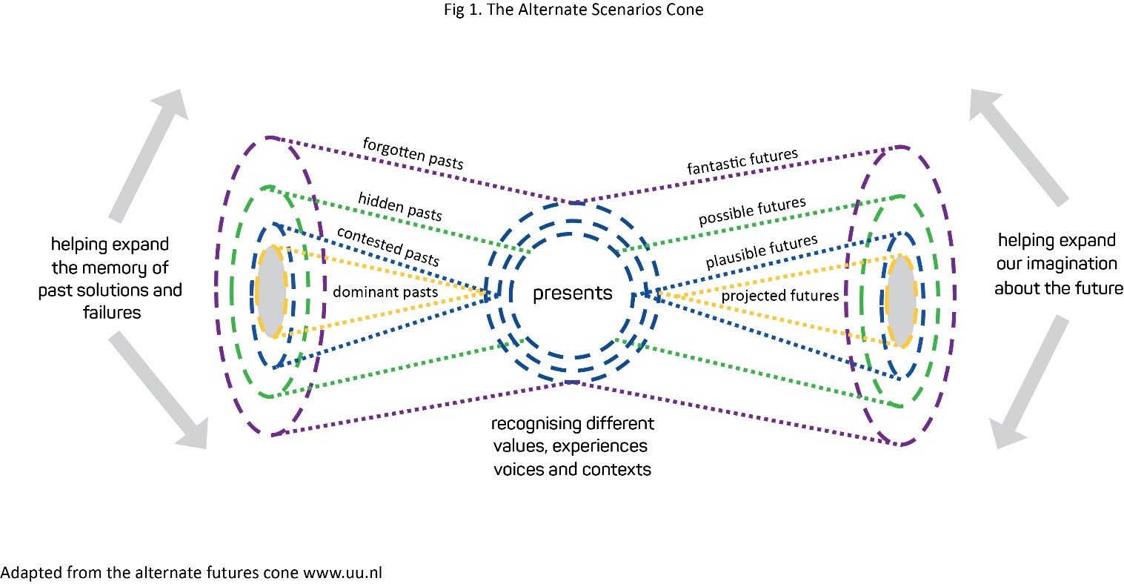

**Example Exercise Concept:**

I want to widen our understanding of the past - what new lessons can we learn?

Or

Let’s explore some different future scenarios so we can imagine a better way of doing things and identify some actions we can take.

* *Note revisiting past events can be triggering and requires careful consideration of, and provision for, participant psychological safety*

Once you have a concept of what you want to explore, it is time to generate some   
“what -if?” questions.

3. Generating “what-if?” questions

The success of a community hypothetical exercise depends on asking the right questions. If questions are too predictable or too narrow, it might limit new learnings from emerging. However, if the questions are too big and difficult it can be confronting, and the discussion can get bogged down in detail.

**Tips for generating “what-if?” questions**

* **Do some research** – what are other similar groups considering? What new risks or hazards are predicted for the future? What is the most dangerous risk that could emerge?
* **Ask around** - what are the issues of concern for different groups in the community? For example, pet owners, the elderly, those with limited mobility, those who live remotely.
* **Challenge your assumptions** - what if something you assumed would always be available was missing? What if things were different?
* **Consider the future generations** - pull together those in your community that are creative thinkers – allow them to imagine what doing disasters differently could involve?
* **Consider the ancestors** – are there learnings from the past that could help us now?
* **Consider nature** – what if we think like a mountain or a river or an animal? Can this give us new perspectives?
* You could consider holding a short **brainstorming session** to generate questions.

Once you have generated a list of questions it is best to narrow them down to a smaller number to be used in the exercise. You will want to consider questions that prompt discussion about what the most demanding or different scenario might look like, as these can provide the deepest insight. Too often, demanding ideas are watered down because they’re too confronting. Different ideas, on the other hand, need careful nurturing, as they often challenge a dominant mindset and can be discarded or discounted. It can be helpful to set different or demanding questions further in the future (or the past) as this can make it easier for participants to talk about.

**Example exercise concept and questions:**

* I want to widen our understanding of disasters that have happened in this area in the past -what lessons can we learn? What if we had to face future disasters with only the technologies that our grandparents had - how would our response have been different?
* What if First Nations peoples had led last year’s recovery effort in X town/region - what would that look and feel like?

Or   
Let’s explore some different futures so we can imagine a better way of doing things and identify some actionable insights.

* What if there was a time when the government couldn’t help during a disaster - how would we step up?
* We have a high risk of flooding. What if we relocated the town up the hill?
* What if we had better safety nets - such as adequate emergency housing and funds? Where could this funding come from and where could housing be built?

* *Note revisiting past events can be triggering and requires careful consideration of, and provision for, participant psychological safety*

Now you have the concept & questions - lets plan your exercise event.

4. Developing a plan

Planning ahead will help ensure that your exercise event runs smoothly. The Planning checklist below provides a guide to what you need to consider.

Planning checklist

**Before you start:**

* + Be clear on your purpose and audience.
  + Have developed aims and objectives.
  + Have developed your scenarios and questions to be addressed.

**Plan the exercise:**

* + Identify your participants/team.
  + Get together.
  + Consider how much time, space, capacity and the resources you have. It may be useful to set a date for the activity and work backwards. Can you get it all done in time? Who will facilitate the exercise on   
    the day?
  + Assign exercise roles. Who will be responsible for actions?
  + Revisit and refine the scenarios and questions. Can we improve them?
  + Identify a venue. Is this venue accessible? Is it an appropriate size?
  + Identify any tools or technologies and catering requirements.
  + Plan your facilitation. **See the companion facilitators guide.**
  + Record the outcomes of your planning session and make sure everyone has a copy.
  + Think about how you might measure the success of the exercise. Consider creating an evaluation form   
    for participants to fill out at the end of the exercise.

**Getting ready to go**

* + Promote the session. Consider putting up posters or sending reminder emails.
  + Conduct rehearsals if needed.
  + Confirm venue and conduct a site visit to check everything works and is safe.
  + Print/gather resources.
  + Distribute any pre-reading literature.
  + Let participants know where, when, what to expect and what to bring.

**On the day**

* + Sign in sheet.
  + Evaluation form (if using).
  + Put up signs/sign in table.

**After the event**

* + Follow up with the participants. Did they enjoy the exercise?
  + Conduct evaluation (if doing).
  + Take action – or make sure you recommended actions reach groups that have the resources to act. Consider social media, local news outlets or briefings to council or emergency services members.

You are now ready to conduct your exercise.

5. Conducting the exercise

There are three main roles on the exercise day. Ideally, you will have a different person assigned for each role (although they can be combined).

* The exercise coordinator – responsible for the whole event, conducts the welcome and close.
* The exercise facilitator – facilitates the exercise.
* The administration and logistics person – looks after the venue, any tools and technologies, and the catering.

If you have a larger group, you may also wish to have a dedicated person who works with the tools and technologies and a facilitators assistant who will also take on the exercise safety role.

The exercise should proceed according to your exercise “run sheet” which you will have prepared when you planned your facilitation. A sample exercise running sheet is provided in the companion Facilitators Guide.

**Facilitation Tip**Exercises rarely run precisely to time and your run sheet is a guide, not an ultimatum. Things will be slower at the start as the group gets to know each other and becomes more familiar with the exercise process. Don’t be too concerned if your first session runs a little over time. Pace the exercise based on the energy on the room. If there is a lively buzzy conversation - things are going well so allow a bit more time. If everyone has gone silent - it is time to move on. Don’t be afraid of finishing early.

6. Closing the loop - using the exercise outcomes

After the exercise you will want to go back to evaluate your aims and objectives to see if these have been met. This can occur at the end of the activity - or you can seek feedback from participants immediately afterwards.

For aims and objectives focussed on learning or discovery you could ask:

* + Did I/we learn something new?
  + Did this surprise us?
  + Do I/we intend to follow up and seek more information?
  + Who need to see the exercise outcomes?

For aims and objectives focussed on building connections and shared understanding you could ask:

* Did I/we form a new connection?
* Are we on the same page regarding…?
* Do I/we intend to follow up to meet again?

It is common to produce a short report of the exercise findings. These can help with directing future planning as well as helping improving practices. This can be a bit of a challenge as the information from the exercise has often been captured on butcher’s paper, whiteboards or sticky notes which require a bit of effort to turn into something useful.

As a minimum, focus on the key learnings and turn these into a short 1 – 2-page summary or “Blink Report.” If the exercise has led to some actionable insights these should be included in the summary. If you have lots of ideas but not much structure, a tag cloud can be useful.

There is lots of free online tag cloud tools that can do this for you. Ideally, report the findings to all participants. It can also be a good idea to have a post activity meeting to decide what to do next.

Consider sharing the exercise report with a range of interested people, the local council, local fire or SES, local media, the state emergency management agency, or the Australian Institute for Disaster Resilience.

