

Companion to Managing Exercises (AIDR 2023)

Australian Disaster Resilience Handbook Collection

A Community “What-if?” Exercise:

Facilitation Guide

This document complements *Managing Exercises* (AIDR 2023). It is available as an online resource on the Australian Disaster Resilience Knowledge Hub: [knowledge.aidr.org.au/resources/handbook-managing-exercises](https://afacau.sharepoint.com/sites/Comms/Shared%20Documents/Marketing/01_PROJECTS/2024/AIDR/Manage%20Exercises%20Toolkit/Hypothetical%20Exercise%20Toolkit/Export/This%20document%20complements%20Managing%20Exercises%20(AIDR%202023).%20It%20is%20available%20as%20an%20online%20resource%20on%20the%20Australian%20Disaster%20Resilience%20Knowledge%20Hub:%20knowledge.aidr.org.au/resources/handbook-managing-exercises/)

Acknowledgement

# This companion was prepared by the Australian Institute for Disaster Resilience with the assistance of Cheryl Durrant.

# Attribution

Where material from this publication is used for any purpose, it is to be attributed to the Australian Institute for Disaster Resilience as follows: A community "what-if" exercise: facilitation guide (AIDR 2024).

In no event shall the Australian Institute for Disaster Resilience be liable for any damages whatsoever, whether in an action of contract, negligence or other tortious action, arising out of or in connection with the use of or reliance on any of the information in this publication.

# Contact

Enquiries regarding the content and any use of this document are welcome at:

The Australian Institute for Disaster Resilience   
Level 1, 340 Albert Street, East Melbourne Vic 3002

Telephone +61 (0) 3 9419 2388

Email **enquiries@aidr.org.au**

## Introduction

## This facilitation guide is designed to be flexible and tailorable, so that you can adapt it to the needs of you and your participants. The guide provides estimated timeframes and suggested activities that can be adjusted to meet your needs.

Suggested Duration

## A community hypothetical exercise can be designed to take as little as one hour. However, it is recommended that you spend at least ½ a day (3 hours) for this type of activity. The exercise run sheet template below is based on a 3-hour activity.

## Structuring the Facilitation

## **Alternate Scenarios:** One of the simplest structures for a “what if?” exercise is to have a conversation around different scenarios. For Example: what if we did A? and what if we did B? or what if A happened? and what if B happened? What if A and B happened at the same time?

## **Before, During, After:** Another commonly used structure for disaster preparedness exercises considers what if something was different in the future - how would this look or change things before, during and after an event?

## **Participation Diamond:** This is a complimentary approach to other structures. This method splits an exercise session into two parts. In the first part the focus is on generating as many ideas as possible (divergent thinking). In the second part, ideas are prioritised, refined, and more detail is added.

## 

## Facilitation Rhythm

## A facilitated session should also have rhythm. Different participants learn and thrive with different facilitation approaches. You should aim to use a combination of solo reflection and writing, sharing in pairs, small group discussion (3-6 participants) and whole group activity to create a facilitation rhythm. Circle between activities a few times -building from lower energy more reflective solo activities through to higher energy whole room activities.

## Suggested Props and Materials

## Why conduct recovery exercises

**Navigating the session**: Participants like to know what is going on and who is in the room. As a minimum, have copy of the facilitation run sheet visible to all participants. You could also consider:

* Using power-point slides.
* Having printed copies of the run sheet at each table or for each participant.
* Using a whiteboard or notice board.
* Nametags or name plates.
* Printed copies of the scenario or questions to be considered.

**Aiding awareness:** If your exercise focuses on a specific aspect of a disaster, or on the natural or built environment you may wish to provide maps or images. You could consider:

* Timeline of a disaster event.
* Hardcopy printed maps.
* Mud-maps (simplified hand drawn or crafted maps on paper or built up using 3 dimensional aids such as blocks, string, Lego, or whatever you have to hand).
* Printed pictures.
* Electronic displays including power-point.

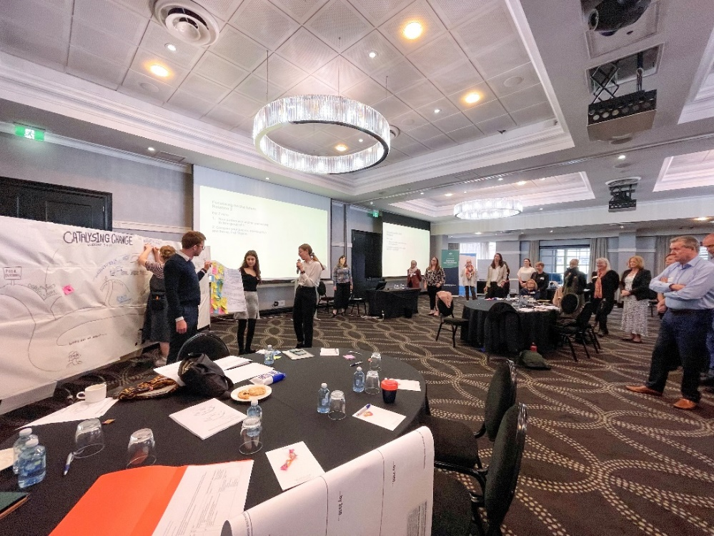

**Capturing Outcomes:** You will likely want to capture the outcomes of the activity. At a minimum you will need pens and paper or other recording devices. You could also consider:

* Whiteboards and whiteboard markers.
* Butchers paper and markers.
* Post it/sticky notes.
* An artist who can draw/create visuals of the conversations.
* An observer who will make observations/take notes and report back.
* An AI Notetaker.

Facilitation Preparation

If you are the facilitator, allow yourself some time to prepare. How much preparation you feel you need is a personal thing and will depend on your experience. If you are not quite sure how things will go and how much time they will take - test them first with friends or conduct a rehearsal. This will help you clarify your directions and timings ahead of the activity. Different styles of facilitation might lend to different levels of preparation. Some people will prepare to the last second, others will be more driven by the events in the room.

# Sample Run Sheet

|  |  |  |
| --- | --- | --- |
| Time | Activity | Notes |
| 0830  30 Minutes | Arriving:  Arrivals, registration, tea and coffee. | Opening 30 minutes before the start time helps with getting everyone there on time and helps start forming connections. |
| 0900  15 Minutes | Welcome (Whole Group):   * Welcome/Introduce self and any other facilitation support members. * Thank participants for arriving. * Welcome or Acknowledgement of County. * Housekeeping and Administrative Remarks (ground rules, support, toilets, exits, phones, timetable). * Safety – let everyone know while not common, these discussions can stir up feelings and emotions and this is normal, and we have a support person (if there), or if no support person, we can stop for a bit or if you want to duck outside that is OK too. | Consider inviting a local Aboriginal or Torres Strait Islander person to attend the exercise to conduct the Welcome to Country.  Acknowledge who is not here - is there a group who has not been able to attend, for example “firefighters” or “future generations” |
| 0915  15 Minutes | Beginning   * Outline the aim and purpose of the activity. * Icebreaker activity & group introductions.   **Facilitation Tip:** If you have a larger group (e.g. 10+) whole group introductions can take up a lot of your time. Instead, get participants to introduce themselves in pairs or groups of three. | Depending on participant numbers you can combine introductions with the icebreaker activity. |
| 0930  45 Minutes | Discovering (solo reflection and then small Group Discussion)   * Considering the scenario “what if? …” * You could focus on one or more of the following impacts:   + What happens in the natural environment (rivers, trees, landscape)?   + What happens in the built environment (buildings, infrastructure)?   + What happens in the social environment (services, networks, support)?   + What happens in the economic environment (business, supplies, money)? * Or you could use sensory cues: what might you be thinking, feeling, seeing, hearing, touching in these circumstances?   **Facilitation Tip:** As a facilitator you should ‘feel’ for the energy in groups. A group that is too quiet may need assistance or task clarification. A group that is dominated by one personality or with raised voices may need an intervention to ensure that all can share and be heard safely.   * Summarise & close the session.   + Conduct a quick summary activity as a whole group- explain the next steps. | For each question allow participants to spend 1-2 minutes in solo reflection and writing before sharing ideas in a group.  Allow what emerges to emerge-don’t force the discovery towards issues you think should be discussed.  Make sure you capture the discission.  Don’t be worried if not all the questions are covered, quality not quantity is more important. |
| 1015  30 Minutes | Break:   * Refreshments * Movement * Reflection * Chatting * Voting   **Facilitation Tip:** The break is an integral part of the activity. It allows participants to reflect and network and embeds learnings. It also allows you to catch up time and re-jig the schedule if necessary. If you allow for 30 minutes in the schedule -you will have 10 minutes up your sleeve if running overtime. | Serve Morning Tea.  If prioritising issues for further discission you can combine the morning tea with a voting activity. |
| 1045  45  Minutes | * Exploring /Converging (small groups): Depending on your selected structure you could consider:   + Another timeframe   + Mixing up the groups   + New scenarios or questions   + Alternative scenarios -what if things were different?   + Focussing on just one or two issues and digging deeper   + Probing for solutions/actions | Go longer (further into the future), broader or deeper into the issues and questions from the previous session - probe for solutions as well as problems. Refine and converge ideas. |
| 1130  15 Minutes | Reflecting (individual or in pairs):   * Personal reflection on what has been learnt (can also be combined with a quick break for those who need it) | Allow time for participants to reflect on what they have learnt or what has surprised them - ask them to write this down - so that learnings are not lost |
| 1145  10 Minutes | Going Forth (Whole Group):   * Share from reflections * Commitments to further action | Ask participants to share what actions they intend to take following the session.  Outline any actions you will be taking. |
| 1200  5 Minutes | Close (Whole Group):   * Thank everyone for their time * Evaluation | For a quick evaluation (1) Ask everyone to raise their hands if they have learnt something new and (2) ask participants to raise their hands if they made a new connection – or use your evaluation sheet. |

# Some Useful Facilitator Techniques

**Ground Rules:** Introduce the specialist support person (if using). Set ground rules that create a safe space for all participants to express their ideas free from judgement or fear of repercussions. These should include giving everyone permission to make mistakes, treating each other with respect, refraining from criticism or personal attack, adherence to time limits, respect for others' opinions, and a focus on constructive feedback. Introduce the “parking lot” if using. The “parking lot” is a space for ideas that have been raised - but a bit tangential to the discussion or which a participant is getting bogged down on. The parking lot recognises the idea as valid - captures it and allows discussion to move on.

**Safety:** Discussion during sessions might remind participants of their own personal experiences. Sudden associations with difficult experiences that have not been fully processed can provoke strong reactions, e.g., sadness, frustration, and maybe sometimes tears and anger. This may seem frightening initially. But it may provide the opportunity.

to demonstrate ways of responding to difficult feelings. Your discretion as a facilitator will determine whether it is appropriate to deal with such issues in the presence of the whole group. Sometimes it is better to do this individually. If you feel it is appropriate to respond within the group, and there is sufficient time, give the participant the necessary space to react and listen to what they say.

**Good questions to ask might be:** “What was it especially in this story, that...? What did you do when ...? How did it affect you when/that...?” Another very helpful response is to acknowledge the reactions and normalise them: “Thank you for sharing such difficult reactions/memories. I’m sure we all appreciated how difficult this has been. Most people would find it extremely painful to go through such a situation.”

If time is limited, you may suggest that the affected person can link up with the designated support person, another participant, or the facilitator can offer to spend some time during a break to follow up with the person. If necessary, let the participant leave the room, but make sure someone accompanies them. Talk to all the participants about the occurrence right after it has happened. If the affected participant returns, make the situation as comfortable as possible and acknowledge that these things can be difficult at times. Ask if any of the participants would like to share any feelings related to this. Hopefully, when these kinds of occurrences arise, they will be dealt with positively. This will reassure participants that it is okay to feel touched or emotionally affected and that this can be handled safely within a group context. You may wish to have information about further support providers, such as mental health hotlines available.

**Dealing with Difficult Participants** If there is a difficult or disruptive participant, it is important that you address this behaviour immediately in order ensure that all other participants feel safe participating in your workshop activities without fear of being judged or attacked by this individual's comments or actions. You can do this by calmly speaking directly with them after an incident has occurred, explaining why their behaviour was inappropriate, setting boundaries around what kind of language/actions are acceptable going forward, and reminding them that they need to respect others' opinions even if they disagree with them (and vice versa). If necessary, you may need to remove them from your workshop completely if they continue behaving inappropriately despite your attempts at addressing it constructively first-although this measure is rarely needed. However, this should be done only as a last resort when all else fails.

# Facilitation Tools and Techniques

**Icebreakers:** An icebreaker is used to assist participants leave day-to-day distractions behind and frames the rest of the session. Some suggestions for icebreakers are:

* What has surprised me? Ask participants to reflect (individually and silently) on what in the news has surprised them in the last 12 months and why. Depending on group size participants then introduce themselves and share in pairs or with the whole group.
* Metaphor: Divide the group into pairs and ask participants to tell each other the animal or natural feature they feel best describes them and why. This information is subsequently shared with the group when participants introduce their partners (not themselves).
* My favourite thing: Divide the group into pairs and ask participants to tell each other about their favourite thing and why. You can vary this question by asking what three things would you save in a disaster.

**Discussion Tools**: Some tools you might use are:

* **Seeing with new eyes:** This method asks participants to view a problem from a different perspective. Different perspectives can include past generations, future generations, culturally and linguistically diverse communities (CALD)-basically anything that is different from the participants normal perspective. Note this technique does not replace or substitute for diversity of participants.
* **Five Whys:** This method is remarkably simple: when a problem occurs, you drill down to its root cause by asking "Why?" five times.
* **Community Lifelines Mapping:** Community lifelines are people centred networks of essential services in the community that enable all other aspects of society to function. The FEMA lifelines toolkit might be helpful for this. [https://www.fema.gov/sites/default/files/documents/fema_lifelines-toolkit-v2.1_2023.pdf](https://www.fema.gov/sites/default/files/documents/fema_lifelines-toolkit-v2.1_2023.pdf%20)

**Tools for Voting/Prioritisation:** When voting on an issue or theme ask participants to vote with the head (use a star) and the heart (use a heart). This method facilitates the emergence of both values and vulnerabilities. There are also online voting and survey tools that can be used.

